[X] Risk Management Policy – CIO Foundation /Association
- Introduction
This risk management policy should be read alongside the Risk Register. Together these documents set out the risk management framework for the charity with a particular focus on allowing the trustees of the charity to:
- identify the major risks that apply to [X];
- make decisions about how to respond to the risks we face; and
- make an appropriate statement regarding risk management in our annual report.

- Review and updates to the risk management framework
We acknowledge that the risk [X] is exposed to need proactive and careful management. To ensure the risk management framework of the charity reflects changing operations, circumstantial and external risks which arise this framework shall be reviewed on:
- a review of risks on a quarterly basis by the trustee board;
- referred to annually for the purpose of our Trustee Annual Report;
- In the event of any Serious Incident occurring;
- circumstantially upon request of a trustee should any substantive risks arise; and
- a full review of the risk register bi-/annually by the Board and stakeholder group.
This will also take into account updates in guidance from the Charity Commission (in particular to CC26) and should be read in conjunction with this guidance: https://www.gov.uk/government/publications/charities-and-risk-management-cc26/charities-and-risk-management-cc26

- [X] Risk Management Approach
- Risk Statement
We will never accept risks that:
- [Compromise the safety of beneficiaries, staff, or volunteers
- Involve illegal or unethical activities
- Could result in loss of charitable status
- Fundamentally conflict with our values and mission
- We cannot adequately monitor or control – for example]

- Categorisation & Appetite by category
Per our risk register risks to the charity are categorised as follows, with any numbered limits on risk enclosed:
- Operational
- External
- Governance & Compliance
- Finance
- Safeguarding ([X] due to low risk tolerance in this area and zero tolerance for incidents to occur)
[We have also identified [X] contextual risks to the charity].
The trustee board acknowledge that these categories are non-exhaustive and will discuss broadly the risks presented to the charity as well as specifically in order to identify any further risks arising.

- Scoring
A risk matrix is used in keeping with the approach advocated by CC26 which scores risk to ensure that the level of risk the charity is exposed to is quantified in the following rationale:
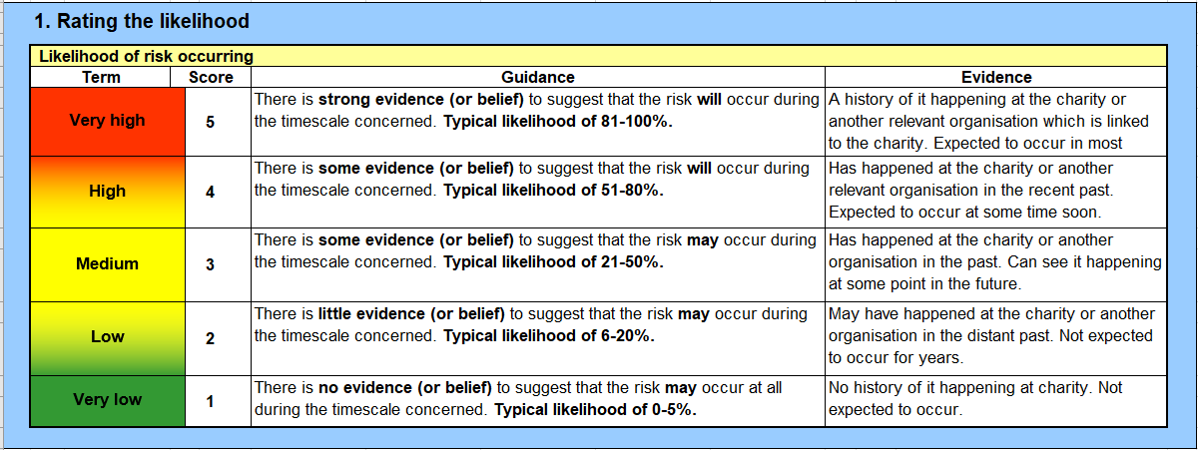
Firstly, the rating likelihood is quantified on a sliding scale of 1-5 increasing in likelihood:
Secondly, the impact of the risk occurring is quantified on a sliding of 1-5. The higher the score the higher the impact: 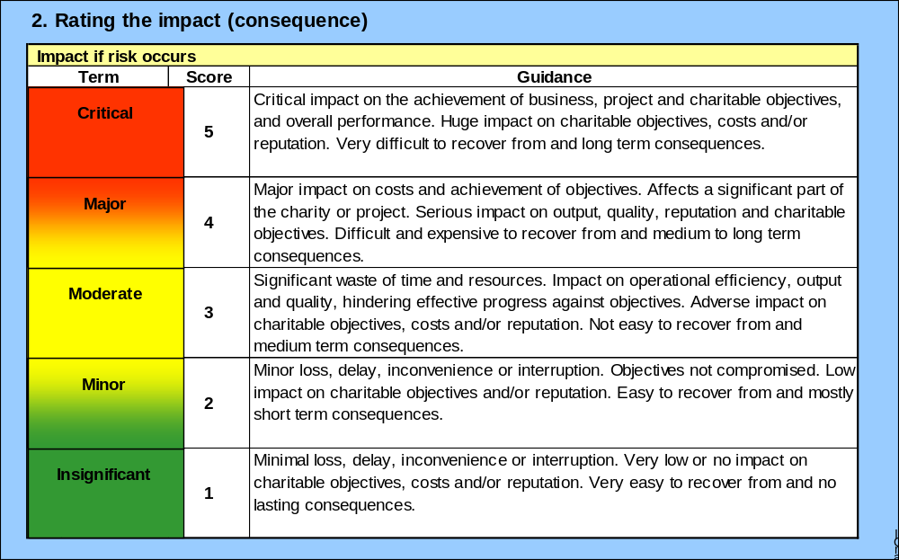
Finally, the scores of likelihood x the impact are calculated resulting in an overall risk score:
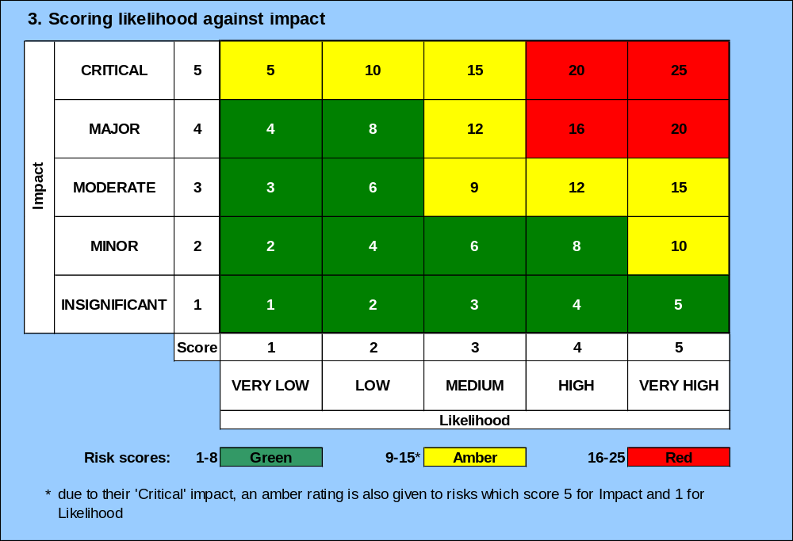

To acknowledge the critical impact of risks which score in this category but only score a 1 for likelihood an amber rating is specified. This reflects the critical impact of any risk categorised as such should it occur.

- Escalation
Any scores [over 15- this is merely a suggestion your appetite may vary] or above will be reviewed by the Board on a quarterly basis and approaches and mitigations agreed and set.

- Risk management approach
The four risk management strategies from the CC26 are acknowledged and considered by the Board in approaching risks which remain unacceptably high and will be accordingly note in the risk register:
- transferring the financial consequences to third parties or sharing it, usually through insurance or outsourcing
- avoiding the activity giving rise to the risk completely, for example by not taking up a contract or stopping a particular activity or service
- management or mitigation of risk
- accepting or assessing it as a risk that cannot be avoided if the activity is to continue: an example of this might be where trustees take out an insurance policy that carries a higher level of voluntary excess or where the trustees recognise that a core activity carries a risk but take steps to mitigate it - public use of a charity’s property such as a village hall would be such a risk

- Mitigations
Mitigations are a key part of our risk management approach. This ensures that, where high levels of risk have been identified, we consider carefully the actions which can be taken to mitigate a particular risk from occurring and enact these strategically.
These mitigations are then listed and assigned a risk owner who is operationally responsible for that particular risk and actioning the mitigations which are required.
Actions on mitigations are reviewed by [X] on a quarterly basis and the Board on a bi/annual basis with reference to the risk register and this policy.
Scoring is conducted post the agreed mitigations to ensure the residual risk is identified, quantified and accepted by the Board or where necessary additional steps are taken to protect and safeguard the charity.
- Reporting
Reporting is a key part of our charity’s obligations around risk management and is important to communicate the risk response the charity has to the public and regulators, including for maintaining public confidence.
The trustees shall complete an annual risk management statement as part of every Trustees Annual Report which is informed by this risk management approach and considers the contextual and holistic risks to the charity.
Any such risk management statement should include:
- an acknowledgement of the trustees’ responsibility;
- an overview of the risk identification process;
- an indication that major risks identified have been reviewed or assessed; and
- confirmation that control systems have been established to manage those risks.
Should the trustee board see fit, due to the charity’s growth or certain more complex activities, to make a more detailed risk management statement it shall broadly include:
- a description of the major risks faced
- the links between the identification of major risk and the operational and strategic objectives of the charity
- procedures that extend beyond financial risk to encompass operational, compliance and other categories of identifiable risk
- the link between risk assessment and evaluation to the likelihood of its occurrence and impact should the event occur
- a description of the risk assessment processes and monitoring that are embedded in management and operational processes
- trustees’ review of the principal results of risk identification processes and how they are evaluated and monitored

- Responsibilities
Whilst the trustee board remain ultimately responsible for the risk management approach of the charity and also the strategic approach to risk management taken, they have delegated the following functions but retain oversight:
[CEO/Charity Manager/Trustee]:
- Updating the risk register and presenting it quarterly at Board and actioning feedback;
- Setting operational approaches to risk for their particular area of responsibility;
- Horizon scanning and response to operational risks including referring these up to the trustee board for review;
- Actioning mitigations to ensure risk for their area of operations is managed in a timely and effective manner.
- Undertake and provide bi-/annual training to Trustees on risk.

- Stakeholder engagement and involvement
The trustee board will invite [funders/member representatives/a beneficiary representative] to the bi-/annual holistic review of the risk register to ensure broad stakeholder input in the identification, quantification and management of risk.

- Review and Monitoring
This policy shall be reviewed on a bi-/annual basis by the trustee board and will be made available for reference by [CEO/Charity Manager/Trustee] to ensure the ongoing monitoring of risk and their formal annual review.
Date Drafted:
Date reviewed and approved by Board:
Signed off by Chair:

